

Practices for Secure Software Report

Table of Contents
Document Revision History 3
Client 3
Instructions 3
Developer 4
1. Algorithm Cipher 4
2. Certificate Generation 4
3. Deploy Cipher 4
4. Secure Communications 4
5. Secondary Testing 4
6. Functional Testing 4
7. Summary 4
8. Industry Standard Best Practices 4

Document Revision History

Version | Date | Author | Comments
1.0 | 4-2-2026 | Kendall Meredith

Client



Instructions

Submit this completed practices for secure software report. Replace the bracketed text with the relevant information. You must document your process for writing secure communications and refactoring code that complies with software security testing protocols.

- Respond to the steps outlined below and include your findings.
- Respond using your own words. You may also choose to include images or supporting materials. If you include them, make certain to insert them in all the relevant locations in the document.
- Refer to the Project Two Guidelines and Rubric for more detailed instructions about each section of the template.

Developer
Kendall Meredith

Algorithm Cipher

The cipher used to address security issues in Artemis Financial’s application is the SHA-256 hashing algorithm, along with the HTTPS protocol.

SHA-256 is part of the SHA-2 family of cryptographic hash functions and is widely used to ensure data integrity. It generates a fixed-length 256-bit hash value from any input data. In this algorithm, the same input will always produce the same output, but even the smallest change results in a completely different hash. This makes it ideal for checksum verification in secure communications.

Since SHA-256 produces a 256-bit hash, it provides a high level of security against brute-force attacks and collision attempts. Unlike older algorithms like MD5 or SHA-1, SHA-256 is resistant to known cryptographic vulnerabilities and is considered secure for modern apps. Because it’s a one-way function, the original data cannot be reconstructed from the hash, ensuring data protection.

SHA-256 and others like it don’t use encryption keys; they rely on mathematical transformations to produce a unique digest. However, secure communication over HTTPS uses both symmetric and asymmetric encryption. Asymmetric encryption is used during the initial handshake to exchange a session key securely. Random number generation is also used during this to ensure key creation and prevent predictability. In this implementation, HTTPS supports both types of encryption. Asymmetric for secure key exchange and symmetric for faster communication once a secure session is established. This approach enhances security and performance.

Earlier cryptographic algorithms have been deprecated due to vulnerabilities, such as collision attacks. Modern security standards now recommend SHA-2 and SHA-3 algorithms. SHA-256 remains one of the most widely adopted and trusted hashing algorithms today and is mainly used in financial systems, secure communications, and blockchain technologies.

Certificate Generation
Insert a screenshot below of the CER file.
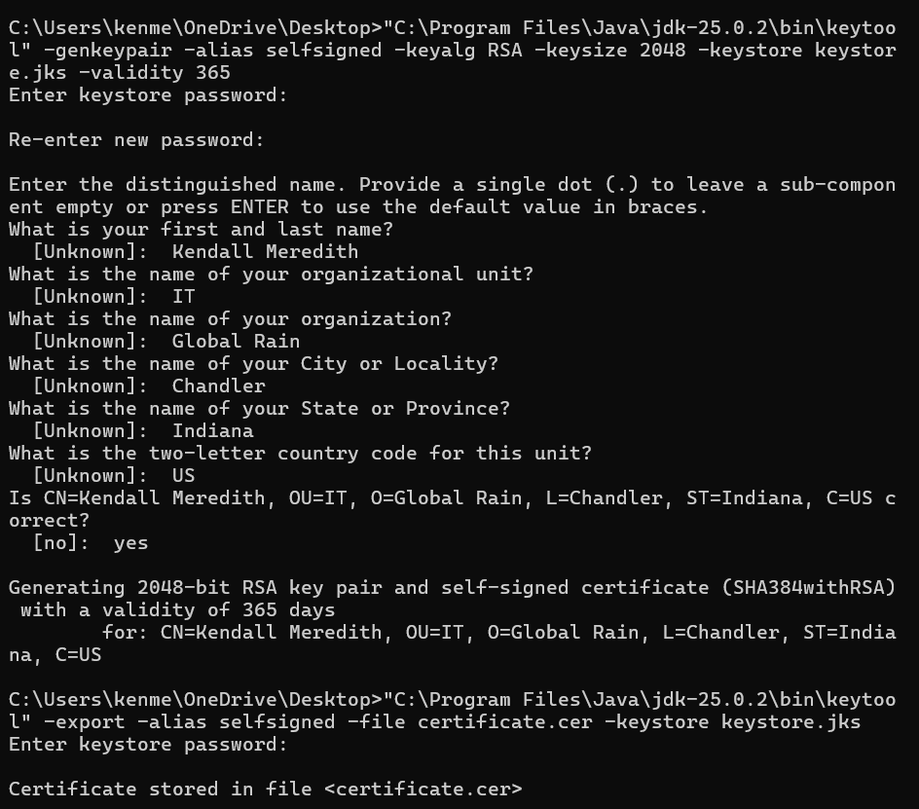

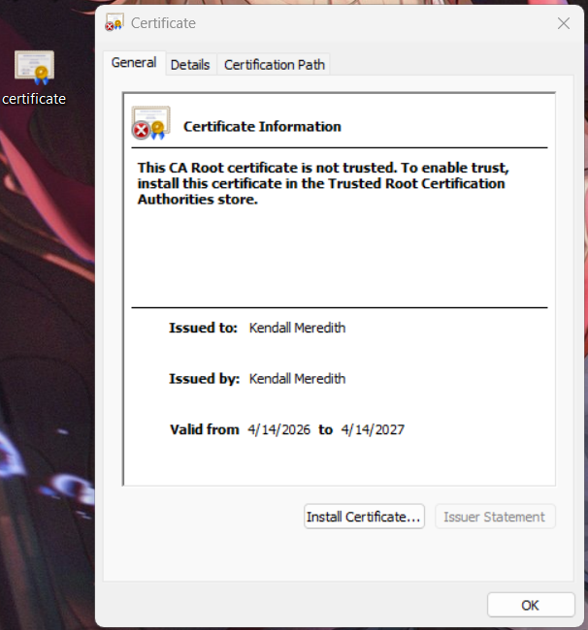

Deploy Cipher
Insert a screenshot below of the checksum verification.

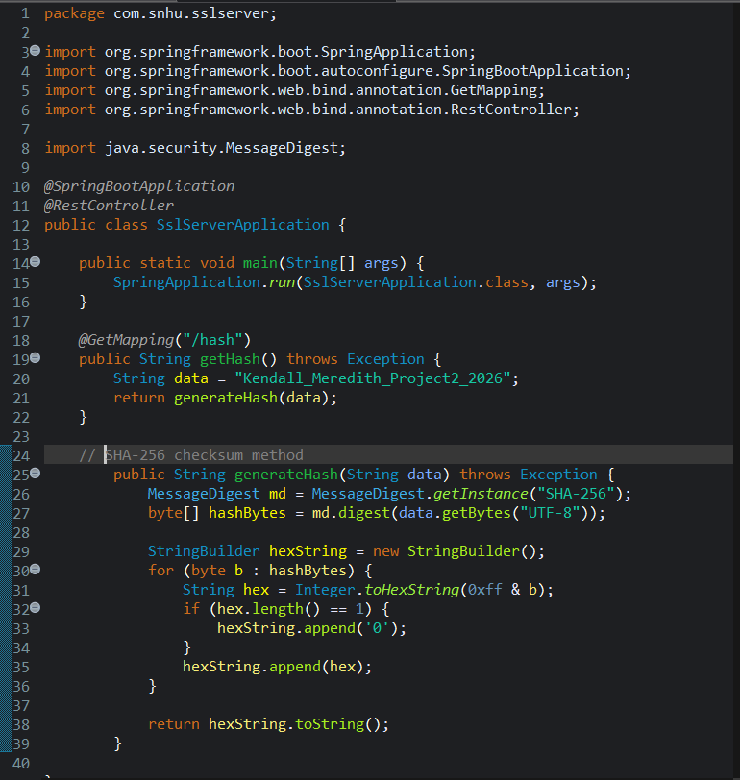

Secure Communications
Insert a screenshot below of the web browser that shows a secure webpage.

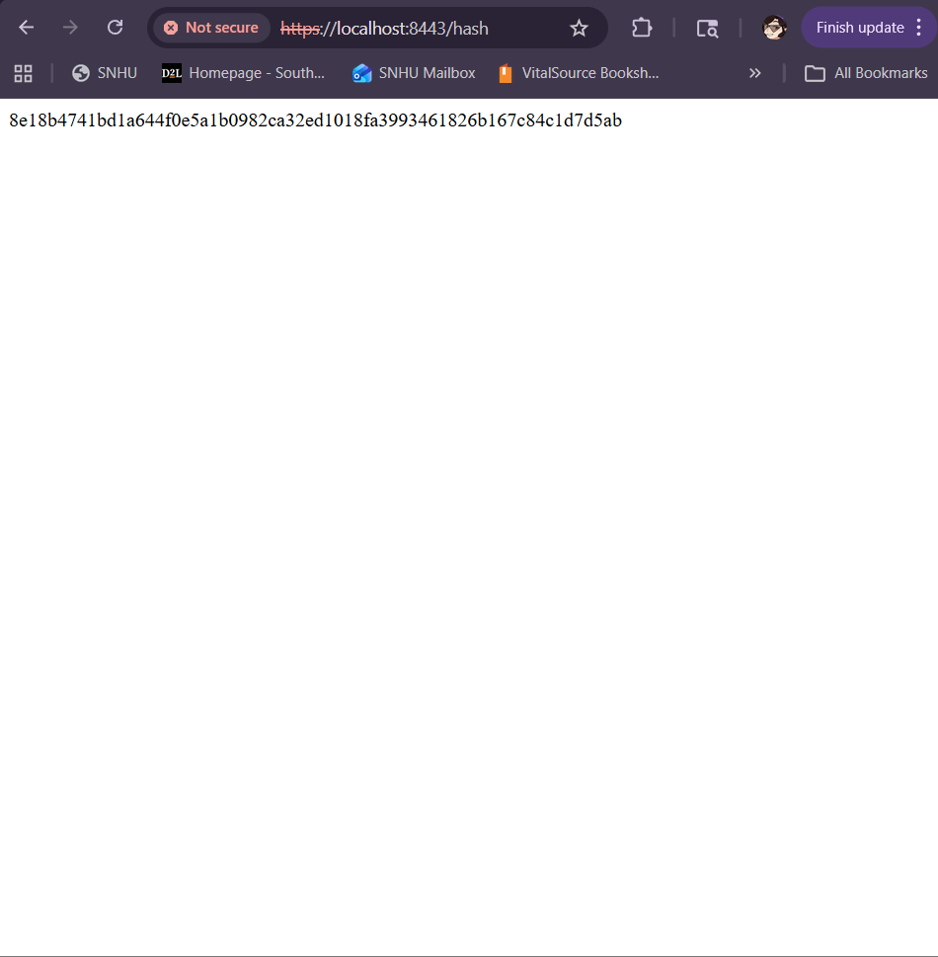

The app was successfully configured to use HTTPS by enabling SSL within the app properties and assigning port 8443 for secure communication. A self-signed certificate was made and used to encrypt data transmitted between client and server

When accessing the app through https://localhost:8443/hash, the browser shows that it’s not secure. This is occurring because it’s a self-signed certificate and not one recognized by a certificate authority. Despite this, communication is still encrypted using TLS protocols.

Secondary Testing
Insert screenshots below of the refactored code executed without errors and the dependency-check report.

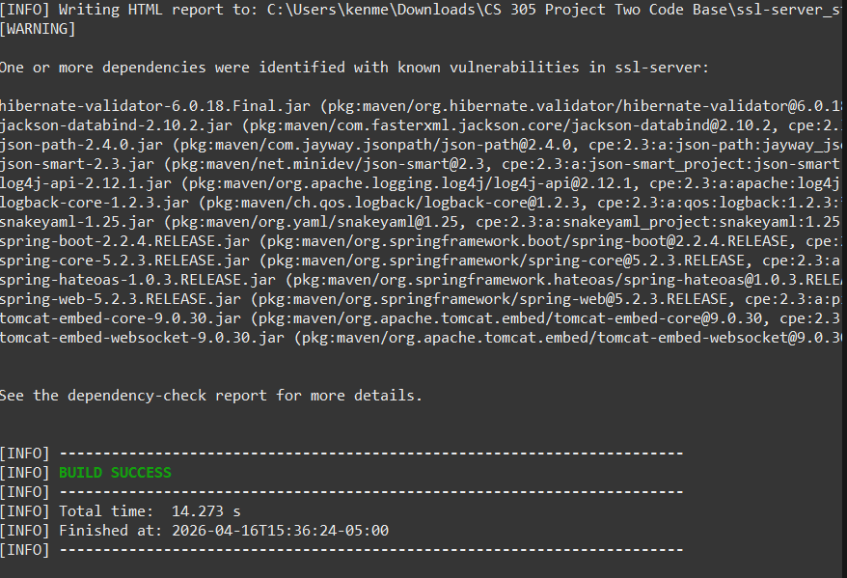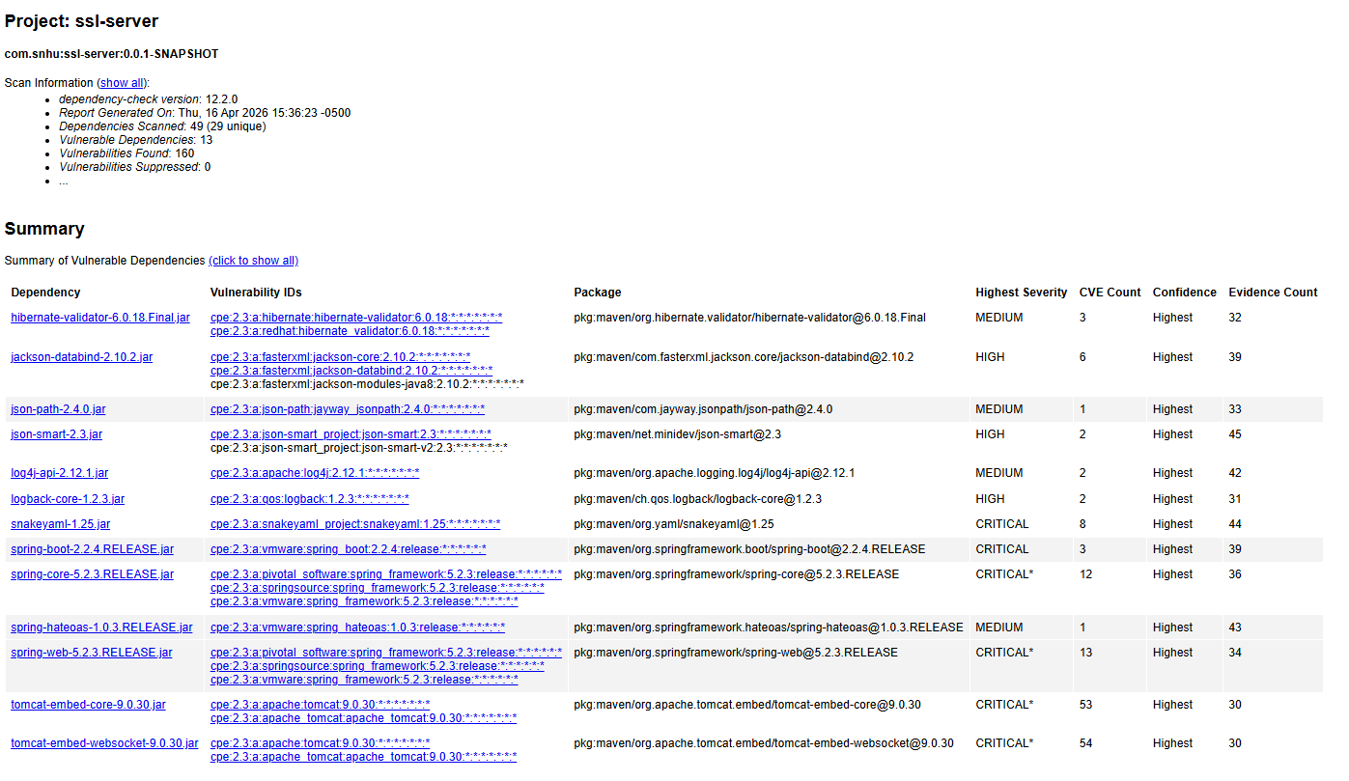
No additional vulnerabilities were introduced. The vulnerabilities present are due to outdated third-party dependencies already in the project. The build was slightly modified to allow the scan to complete without fail.

Functional Testing
Insert a screenshot below of the refactored code executed without errors.

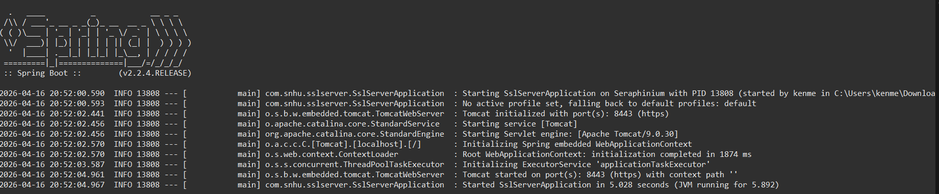

Functional testing was performed by manually reviewing the app code and executing the program to ensure proper functionality.
The code was reviewed to confirm there are no syntax errors and that all required imports and dependencies were correctly implemented. Logical testing verified that the /hash endpoint correctly processes input data and returns a SHA-256 checksum as expected.
Security testing was also performed to ensure that secure communication was enforced using HTTPS and that the hashing algorithm was properly implemented without exposing sensitive data.
The app successfully ran without errors, and all features function as intended. This confirms that the refactored code meets both functional and security requirements.

Summary

In this project, I refactored the Artemis Financial app to improve its overall security and make sure it follows the proper practices. One of the main changes made was adding a SHA-256 hashing function to create a checksum. This helps make sure that data hasn’t been altered during the transmission; even the smallest change will produce a completely different hash. The app was also configured to use HTTPS instead of HTTP by setting up SSL on port 8443 and using a self-signed certificate. This allows data being sent between client and server to be encrypted, which is important for protecting sensitive financial information.

As part of the vulnerability assessment process, I reviewed the code, made the necessary updates, and tested everything to make sure it worked correctly. I also ran a dependency check to see if there were any known vulnerabilities and to confirm that the changes I made didn’t introduce any new security issues.

Industry Standard Best Practices

While working on this project, several industry-standard best practices were followed to improve the app’s security. One of the main things was using SHA-256 for hashing instead of the older algorithms like MD5 or SHA-1. This helps protect against things like collisions and makes the checksum more reliable. I also made sure the app uses HTTPS, which is the standard for secure communication. This ensures that any data being transferred is encrypted and protected from being intercepted. Another important step was testing the app after making changes to ensure nothing broke and that no new vulnerabilities were introduced. I also used dependency-check to scan for known issues in third-party libraries, which is something devs commonly do to maintain security over time.

Using these practices helps keep the app secure while also maintaining its original functionality. It’s important for a company like Artemis Financial because it protects user data, reduces the risk of security breaches, and helps build trust with clients. Following secure coding practices like these is essential for creating reliable and safe software.

